PROJECT DOCUMENTATION
MACHINE LEARNING DATA ANALYSIS USING PYTHON

Title | Laptop Market Intelligence System for Price Segmentation Using Machine Learning
Name | S. KRISHNA KUMAR
Course | DADS
Batch | JULY 2025

TABLE OF CONTENT
SL.NO | CONTENT
 | Introduction
 | Project Objective and Scope
 | Business Problem Statement
 | End-to-End Project Workflow
 | Data Understanding
Data Cleaning and Preprocessing
- Missing Values Imputation
- Outlier Treatment
- Handling Inconsistent Values
- Numeric Feature Imputation
- Encoding of Categorical Variables
 | Feature Engineering and Transformation
 | Filtering Data for Analysis
Exploratory Data Analysis (EDA)
- Univariate Analysis
- Bivariate Analysis
- Multivariate Analysis
 | Unsupervised Learning and Market Segmentation
 | Insights from Exploratory and Clustering Analysis
 | Supervised Model Development
 | Model Evaluation and Validation
 | Model Persistence and Artifact Management
 | Application Deployment Using Streamlit
 | Conclusion and Key Takeaways
 | Limitations and Future Enhancements
- INTRODUCTION
The rapid growth of e-commerce platforms has made a vast amount of product data publicly accessible, enabling data-driven analysis of consumer markets. In this project, laptop specification and pricing data were collected through web scraping from Flipkart, one of India’s largest online retail platforms. The scraped dataset captures real-world market information, including laptop brands, series, processors, memory configurations, storage capacity, display specifications, weight, operating systems, user ratings, and pricing details. However, raw web-scraped data is often unstructured, inconsistent, and noisy, making it unsuitable for direct analysis or modelling
To address this challenge, the project applies systematic data cleaning, preprocessing, and feature engineering techniques to transform raw Flipkart data into a structured and reliable analytical dataset. Using this processed data, exploratory data analysis and machine learning models are employed to identify patterns and classify laptops into meaningful price-based market segments. The project ultimately delivers an end-to-end analytical solution that converts web-scraped e-commerce data into actionable market intelligence and supports real-time prediction through an interactive application.
- Project Objective and Scope

- Develop an end-to-end machine learning system to classify laptops into price-based market segments.
- Utilize real-world laptop data scraped from Flipkart to ensure practical relevance.
- Apply data cleaning, preprocessing, and feature engineering to convert raw web-scraped data into a structured dataset.
- Perform exploratory data analysis (EDA) to identify trends, patterns, and relationships in laptop specifications and pricing.
- Use unsupervised learning techniques to understand natural market segmentation.
- Build and evaluate supervised machine learning models for accurate price category prediction.
- Ensure model robustness and generalization through proper validation.
- Persist trained models and preprocessing artifacts for reuse.
- Deploy the final solution using Streamlit for real-time, interactive predictions.
- Design the system to be scalable and extensible for future enhancements and additional data sources.

- Business Problem Statement

- The laptop market offers a wide range of devices with varying specifications, making price and market positioning difficult to assess based on features alone.
- Consumers often lack clarity on whether a laptop configuration belongs to a Low, Medium, High, or Premium segment.
- Manual evaluation of laptop pricing is time-consuming, inconsistent, and subjective.
- Retailers and sellers require data-driven tools to support pricing strategies and product positioning.
- Raw e-commerce data is unstructured and noisy, limiting its direct use for decision-making.
- There is a need for an automated, scalable solution that converts laptop specifications into meaningful market insights.
- The project addresses this gap by leveraging machine learning models to predict laptop price segments accurately.

- End-to-End Project Workflow

- Collect laptop data through web scraping from Flipkart, capturing real-world market information.
- Store and organize raw data in CSV / database formats for further processing.
- Perform data cleaning and preprocessing to handle missing values, inconsistencies, and incorrect data types.
- Apply feature engineering and transformation to derive meaningful analytical variables.
- Conduct exploratory data analysis (EDA) to understand distributions, relationships, and trends.
- Use unsupervised learning techniques to identify natural market segments.
- Develop supervised machine learning models to predict price categories.
- Evaluate model performance using appropriate validation metrics.
- Save trained models and preprocessing artifacts for reuse.
- Deploy the complete solution using a Streamlit-based interactive application for real-time predictions.
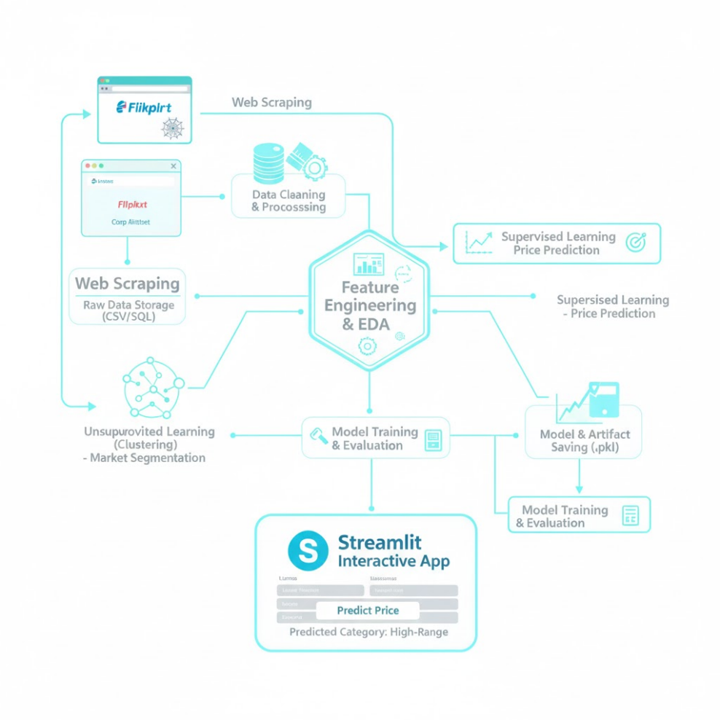
Figure 1 Project Workflow Diagram
- DATA UNDERSTANDING
The dataset consists of real-world laptop product information collected through web scraping from the Flipkart e-commerce platform. It is designed to support the analysis of laptop specifications, pricing behavior, and market positioning across different brands and configurations. The data integrates technical specifications, pricing details, and user perception metrics, enabling a comprehensive examination of factors that influence laptop price segmentation and market classification.
Dataset Overview
- Total Records: Approximately 1000+ laptop listings
- Total Features: 18+ attributes
- Target Variable: Price_Category (Low, Medium, High, Premium)
Key Variables
A. Brand and Product Attributes
- Brand: Manufacturer of the laptop (e.g., HP, Dell, Lenovo, Apple).
- Series: Product line or model series representing market positioning.
- Product URL: Unique URL identifying each laptop listing (removed during modeling).
B. Hardware and Technical Attributes
- CPU: Processor type and generation, a key determinant of performance and price.
- GPU: Graphics processor, indicating suitability for gaming or professional workloads.
- RAM: Memory capacity, extracted and standardized from textual formats.
- Storage: Storage capacity (GB/TB), representing data handling capability.
- Display: Screen size in inches, affecting usability and form factor.
- Weight: Physical weight of the laptop, relevant for portability analysis.
- Operating System: Pre-installed OS such as Windows, macOS, or Chrome OS.
C. Pricing and Discount Attributes
- Price (Rs): Current selling price of the laptop.
- Original Price (Rs): Listed original price before discount.
- Discount Percentage: Extracted discount value indicating promotional pricing.
D. User Perception Attributes
- Rating: Average user rating reflecting customer satisfaction.
- Review Count: Number of user reviews, representing popularity and trust.
E. Target Attribute
- Price Category
Generated by segmenting the laptop price into four meaningful market segments:
- Low
- Medium
- High
- Premium

- DATA UNDERSTANDING
Since the dataset was collected through web scraping from an e-commerce platform, it contained missing values, inconsistent formats, and unstructured text. Data cleaning and preprocessing were essential to ensure data quality, consistency, and suitability for analysis and machine learning models.
Missing Values Imputation
- Several attributes such as RAM, Storage, Display, Weight, Rating, and Reviews contained missing or “Not Available” values.
- Numerical features were converted to numeric data types and missing values were imputed using the median, ensuring robustness against outliers.
- Categorical missing values were handled using placeholder labels or filtered where necessary.
Outlier Treatment
- Extreme values in numerical attributes such as price, RAM, storage capacity, and weight were identified during exploratory analysis.
- Outliers were examined to distinguish genuine high-end laptops from data errors.
- Unrealistic values were capped or removed to prevent distortion in model training.
Handling Inconsistent Values
- Textual inconsistencies such as different unit representations (GB, TB, Inches, KG) were standardized.
- Irregular entries like “Not Available”, symbols, and mixed text were cleaned and normalized.
- Price and discount values were extracted from raw text and converted into numeric form.
Numeric Feature Imputation
- RAM and storage values were converted into GB units for uniformity.
- Display size and weight were parsed from textual descriptions into numeric formats.
- Invalid or corrupted numeric entries were coerced and corrected.
Encoding of Categorical Variables
- Categorical features such as Brand, Series, CPU, GPU, and Operating System were encoded using Label Encoding.
- Encoders were stored and reused during deployment to maintain consistency between training and prediction stages.

- DATA UNDERSTANDING
Feature engineering plays a critical role in improving model performance by transforming raw attributes into meaningful analytical features. In this project, multiple transformations were applied to enhance the predictive power of the dataset and ensure compatibility with machine learning algorithms.
Derived Feature Creation
- A new target variable, Price_Category, was created by segmenting the laptop price into meaningful market ranges.
- Price values were grouped into four classes: Low, Medium, High, and Premium, representing different market segments.
- Discount percentage was derived from original and selling prices to capture promotional impact.
Feature Transformation
- Numerical features such as RAM, Storage, Display Size, Weight, and Rating were standardized using StandardScaler.
- Scaling ensured uniform feature contribution during model training.
- Text-based features were transformed into structured formats suitable for modeling.
Feature Selection
- Only relevant features influencing laptop pricing were retained.
- Redundant and non-informative attributes such as raw specification text and product URLs were removed.
- Feature selection helped reduce noise and improve model stability.
Consistency Across Pipelines
- The same transformation logic was applied during both training and deployment.
- Feature order and data types were preserved to avoid inconsistencies at prediction time.
- FILTERING DATA FOR ANALYSIS
After feature engineering, the dataset was filtered to ensure that only high-quality, relevant data was used for analysis and model development. This step was essential to improve the reliability and interpretability of both exploratory analysis and machine learning results.
Data Quality Filtering
- Records with missing or invalid values in critical features such as Price, RAM, Storage, CPU, and Brand were removed.
- Rows containing incomplete specification information that could negatively impact model performance were excluded.
- Duplicate laptop listings were identified and eliminated to avoid bias.
Feature-Based Filtering
- Only features required for EDA, clustering, and supervised modeling were retained.
- Non-essential columns such as raw specification text, original product URLs, and intermediate parsing fields were removed.
- Ensured consistency of features across training, evaluation, and deployment stages.
Analysis Readiness
- The final filtered dataset contained clean, structured, and standardized data.
- This prepared dataset served as the foundation for exploratory analysis, unsupervised learning, and supervised model training.

- EXPLORATORY DATA ANALYSIS (EDA)
Exploratory Data Analysis was conducted to understand the underlying structure of the dataset, identify patterns, and examine relationships between laptop specifications and pricing. EDA helped validate assumptions, detect anomalies, and guide feature selection and modeling decisions.
Univariate Analysis
- Analyzed the distribution of individual variables such as Price, RAM, Storage, Display Size, Weight, and Ratings.
- Identified skewness and concentration in price ranges across the laptop market.
- Observed frequency distribution of categorical features such as Brand, CPU type, GPU type, and Operating System.
- Helped distinguish common configurations from niche or premium offerings.
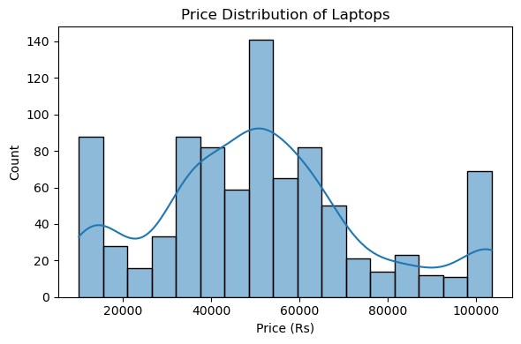
Figure 2 Price Distribution (Laptop)
Bivariate Analysis
- Examined relationships between Price and key specifications such as RAM, CPU, GPU, and Storage.
- Analyzed how pricing varies across different brands and product series.
- Studied the impact of user ratings and review counts on laptop pricing.
- Identified strong correlations between high-performance components and higher price segments.
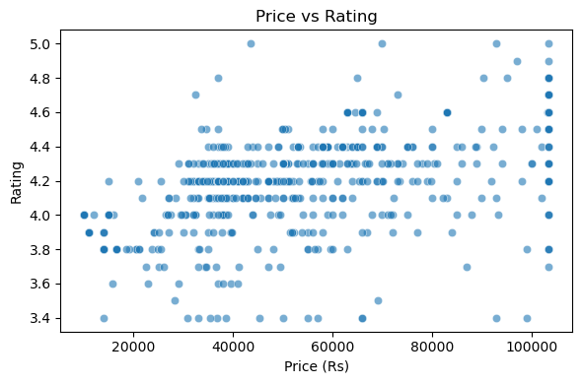
Figure 3 Price & Rating (Scatterplot)
Multivariate Analysis
- Analyzed the combined influence of multiple features on laptop pricing.
- Explored interactions between CPU, GPU, RAM, and Storage across different market segments.
- Used dimensionality reduction techniques to visualize complex relationships.
- Supported a deeper understanding of how multiple specifications collectively define market positioning.
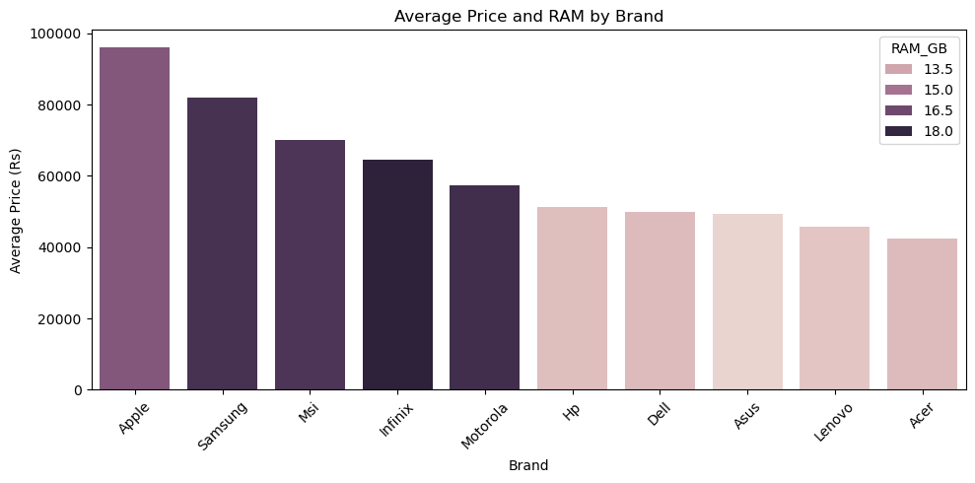
Figure 4 Avg.Price & RAM by Brand
- UNSUPERVISED LEARNING AND MARKET SEGMENTATION

Unsupervised learning techniques were applied to identify natural groupings within the laptop market based on technical specifications and pricing-related features. This step aimed to uncover hidden structures in the data without relying on predefined labels, providing deeper insight into market segmentation.

Feature Scaling

- Numerical features were standardized to ensure equal contribution during clustering.

- Scaling prevented features with larger magnitudes, such as price or storage, from dominating the clustering process.

Clustering Approach

- K-Means Clustering was used to segment laptops into distinct groups.

- The Elbow Method was applied to determine the optimal number of clusters.

- Silhouette Score was used to evaluate the quality and separation of clusters.

Dimensionality Reduction

- Principal Component Analysis (PCA) was employed to reduce dimensionality.

- PCA enabled visualization of clusters in a lower-dimensional space.

- Helped interpret how laptops with similar specifications grouped together.

Market Segmentation Interpretation

- Identified clusters representing entry-level, mid-range, high-performance, and premium laptops.

- Observed that performance-heavy configurations clustered distinctly from budget-oriented models.

- Provided valuable insights to support supervised model development and price category definition.

- INSIGHTS FROM EXPLORATORY AND CLUSTERING ANALYSIS
Insights derived from exploratory data analysis (EDA) and unsupervised learning provided a comprehensive understanding of pricing behavior and market structure within the laptop industry. The combination of statistical analysis and clustering techniques helped uncover patterns in laptop specifications, validate pricing assumptions, and inform the design of the supervised learning model.
Key Insights from Exploratory and Clustering Analysis
- Laptop pricing is strongly influenced by CPU type, RAM capacity, storage size, and GPU availability, making performance-related features the primary drivers of market segmentation.
- Premium laptop clusters are dominated by high-end processors, dedicated GPUs, larger RAM capacities, and higher storage configurations, reflecting performance-oriented and professional use cases.
- Mid-range laptops form dense and well-defined clusters characterized by balanced specifications, offering optimal price-to-performance ratios.
- Entry-level laptops exhibit limited variation in specifications and are primarily distinguished by affordability rather than performance features.
- Brand reputation plays a significant role in price differentiation, particularly within higher market segments.
- User ratings tend to be higher for mid-range and premium laptops, indicating greater customer satisfaction and perceived value.
- The clustering results closely aligned with the derived price categories, validating the segmentation logic used for supervised modeling.
Clustering Methods Used
To identify natural groupings within the laptop market and ensure reliable segmentation, multiple unsupervised learning and validation techniques were applied. Each method contributed uniquely to the robustness and interpretability of the clustering results.
1. K-Means Clustering
K-Means was selected as the primary clustering algorithm due to its efficiency, simplicity, and suitability for scaled numerical data.
- The algorithm partitions data into K clusters by minimizing the within-cluster sum of squares (WCSS).
- Each laptop is assigned to the nearest cluster centroid based on Euclidean distance.
- This approach is well-suited for grouping laptops with similar configurations into compact, well-separated market segments.
Purpose in this project:
- To group laptops into meaningful market segments based on specifications such as RAM, storage, display size, weight, and rating.
- To identify natural divisions such as budget, mid-range, high-performance, and premium categories.
2. Elbow Method
The Elbow Method was used to determine the optimal number of clusters (K).
- WCSS values were computed for different values of K.
- As K increases, WCSS decreases; however, beyond a certain point, the rate of improvement slows.
- The “elbow point” represents the optimal balance between clustering accuracy and model complexity.
Purpose in this project:
- To objectively select the number of clusters that best represent the laptop market structure.
- To prevent over-clustering or under-clustering of data.
3. Silhouette Score Analysis
The Silhouette Score was used to evaluate clustering quality and separation.
- Measures how similar each data point is to its own cluster compared to other clusters.
- Scores range from –1 to +1, where higher values indicate better-defined clusters.
Purpose in this project:
- To validate cluster consistency and separation.
- To support the choice of K identified through the Elbow Method.
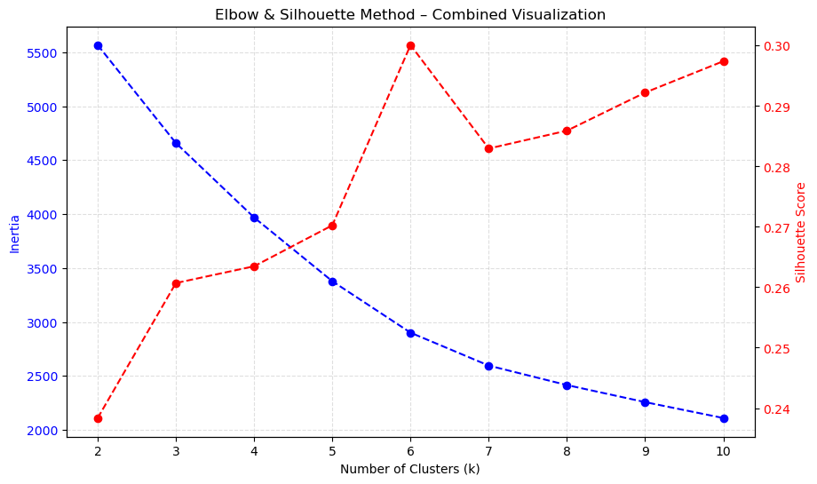
Figure 5 Elbow & Silhouttee
4. Principal Component Analysis (PCA)
Principal Component Analysis was applied as a dimensionality reduction technique to assist with cluster interpretation and visualization.
- Reduces high-dimensional feature space while preserving maximum variance.
- Enables visualization of clusters in two- or three-dimensional space.
Purpose in this project:
- To visually inspect cluster separation.
- To understand how combinations of features influence market segmentation.
- To enhance interpretability of clustering outcomes.
Impact on Market Analysis
The combined use of exploratory analysis and clustering techniques ensured:
- Data-driven and interpretable market segmentation
- Strong alignment between unsupervised clusters and supervised price categories
- A robust analytical foundation for accurate price segment prediction and model development.
- SUPERVISED MODEL DEVELOPMENT
After deriving meaningful insights from exploratory analysis and unsupervised clustering, supervised machine learning techniques were applied to build a predictive model capable of classifying laptops into predefined price-based market segments. The objective of this stage was to learn patterns from labeled data and accurately predict the Price_Category for unseen laptop configurations.
Target Variable Definition
- The target variable, Price_Category, was created by segmenting the actual laptop prices into four meaningful classes:
  - Low
  - Medium
  - High
  - Premium
- This transformation converted a continuous pricing variable into a classification problem aligned with business use cases.
Feature Selection
- Input features selected for model training included:
  - Brand, Series, CPU, GPU, Operating System
  - RAM, Storage, Display Size, Weight, Rating
- Irrelevant and non-predictive attributes such as raw text specifications and product URLs were excluded to reduce noise.
Data Preparation
- Categorical variables were transformed using Label Encoding.
- Numerical features were standardized using StandardScaler to ensure uniform feature contribution.
- The dataset was split into training and testing sets to evaluate model generalization.
Model Selection
- A Random Forest Classifier was chosen as the supervised learning model due to:
  - Its ability to handle both categorical and numerical features
  - Robustness to noise and overfitting
  - Capability to capture non-linear relationships
- The ensemble approach improved prediction stability and accuracy.
Model Training
- The model was trained on the processed training dataset.
- Multiple decision trees were built and aggregated to form the final prediction.
- Random state control ensured reproducibility of results.
Outcome
The supervised learning model successfully learned complex relationships between laptop specifications and price categories. The trained model served as the core prediction engine for deployment, enabling accurate and reliable market segment classification for real-time user inputs.
- MODEL EVALUATION AND VALIDATION
Model evaluation was conducted to assess the performance, reliability, and generalization capability of the supervised learning model. This step ensured that the trained model could accurately predict laptop price segments on unseen data and deliver consistent results in real-world scenarios.
Evaluation Strategy
- The dataset was divided into training and testing sets, ensuring unbiased performance assessment.
- Predictions on the test set were compared against actual price category labels.
- Multiple evaluation metrics were considered to obtain a comprehensive view of model performance.
Performance Metrics
- Accuracy: Measured the overall correctness of price category predictions.
- Classification Performance: Evaluated how well the model distinguished between different price segments.
- Error Analysis: Identified cases of misclassification to understand model limitations.
Validation Results
- The Random Forest model demonstrated strong predictive performance across all price categories.
- The model showed higher confidence and accuracy in mid-range and premium segments, where specification patterns were more distinct.
- Minor overlaps between adjacent price segments were observed, which is expected due to gradual price transitions in the market.
Model Robustness
- The ensemble nature of the Random Forest reduced overfitting and improved generalization.
- Feature scaling and consistent preprocessing ensured stable predictions.
- Validation confirmed the model’s suitability for deployment in a real-time application.
- MODEL PERSISTENCE AND ARTIFACT MANAGEMENT
Model persistence and artifact management are essential to ensure that the trained machine learning model can be reused reliably without retraining. In this project, all critical components of the modeling pipeline were stored and managed systematically to support seamless deployment and future scalability.
Persisted Artifacts
- The trained Random Forest model was saved using efficient serialization techniques.
- The feature scaler (StandardScaler) used during training was persisted to maintain consistency during inference.
- Label encoders for categorical variables were stored to ensure correct transformation of user inputs at prediction time.
Consistency Across Pipelines
- The same preprocessing steps applied during training were reused during deployment.
- Feature ordering and data types were preserved to prevent runtime errors and prediction inconsistencies.
- Persisted artifacts ensured identical data transformations for both training and real-time inference.
Reusability and Scalability
- Model persistence eliminated the need for retraining when restarting the application.
- Stored artifacts allow easy model updates, versioning, and experimentation.
- The approach supports future integration with APIs, cloud deployment, or additional data sources.
Operational Reliability
- Artifact management improved system reliability and reduced dependency on manual intervention.
- Ensured stable and reproducible predictions across multiple sessions.
- APPLICATION DEPLOYMENT USING STREAMLIT
The final stage of the project involved deploying the trained machine learning model as an interactive web application using Streamlit. The deployment enables users to analyze laptop configurations and receive real-time market segment predictions through a user-friendly interface.
Application Architecture
- The Streamlit application integrates the trained model, scaler, and encoders to ensure consistent preprocessing and prediction.
- A modular structure separates the user interface, preprocessing logic, and prediction pipeline.
- Cached resource loading improves application performance and responsiveness.
User Interface Design
- The interface allows users to select laptop attributes such as brand, series, CPU, GPU, operating system, RAM, storage, display size, weight, and rating.
- Brand-based dynamic filtering ensures that only valid configuration options are displayed.
- The layout is designed to be intuitive, readable, and visually structured for ease of use.

Figure 6 UI Design on Laptop Market Analysis
Prediction Workflow
- User inputs are transformed using the persisted encoders and scaler.
- The processed input is passed to the trained Random Forest model.
- The application predicts the corresponding price category (Low, Medium, High, Premium).
- Results are displayed with clear labels and visual emphasis to enhance interpretability.
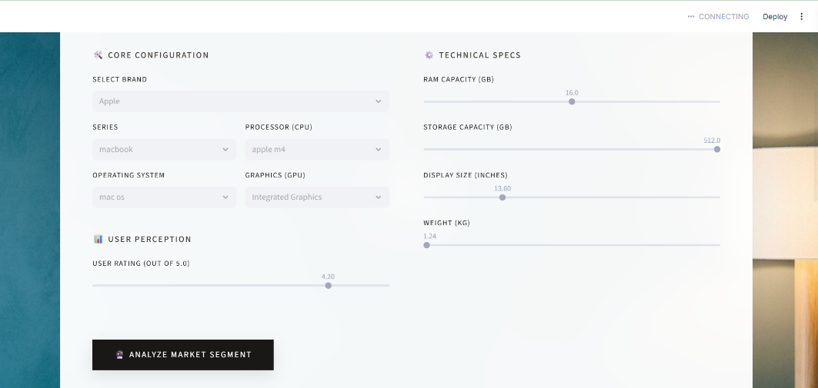
Figure 7 Model Prediction interface
Business and User Value
- Enables real-time price segment analysis without manual evaluation.
- Supports informed decision-making for buyers, sellers, and analysts.
- Demonstrates practical application of machine learning in a real-world scenario.

Figure 8 Model Prediction with Business Insight
- CONCLUSION AND KEY TAKEAWAYS
This project presents an end-to-end machine learning solution for analyzing and segmenting the laptop market using real-world data scraped from Flipkart. The workflow includes data cleaning, feature engineering, exploratory data analysis, unsupervised clustering, and supervised model development. Clustering techniques were used to identify natural market segments, while a Random Forest classifier was trained to predict laptop price categories based on technical specifications and user ratings. The final model was deployed using a Streamlit web application, enabling real-time market segment prediction for user-defined laptop configurations. Overall, the project demonstrates how raw e-commerce data can be transformed into actionable market intelligence to support data-driven pricing and purchasing decisions.
- Limitations and Future Enhancements
Limitations
- The model relies on historical web-scraped data, which may not fully reflect real-time market price fluctuations.
- Pricing overlap between adjacent segments can lead to minor misclassifications.
- Feature set is limited to available listing information and does not include factors such as battery life, build quality, or after-sales service.
Future Enhancements
- Integrate real-time data pipelines to capture dynamic price changes.
- Explore advanced models (e.g., Gradient Boosting or Deep Learning) for improved accuracy.
- Expand features to include battery performance, display quality, and warranty details.
- Deploy the application as a cloud-based API and extend it into a recommendation system.

